**Ex. No.:8 Date:16-10-2020**

**Line and Load Regulation using Zener diode**

**Aim :**

To understand the application of Zener voltage in the area of Voltage regulation using OrCAD Pspice software.

**Apparatus/Tool required:**

ORCAD / Capture CIS --> **Analog Library – R,**

**Source Library – Vdc, Idc &**

**Diode Library - Zener diode D1N750**

**Ground (GND) – 0 (zero)**

Simulation Settings: **Analysis Type - Bias Point**

**Circuit Diagram (indicative)**

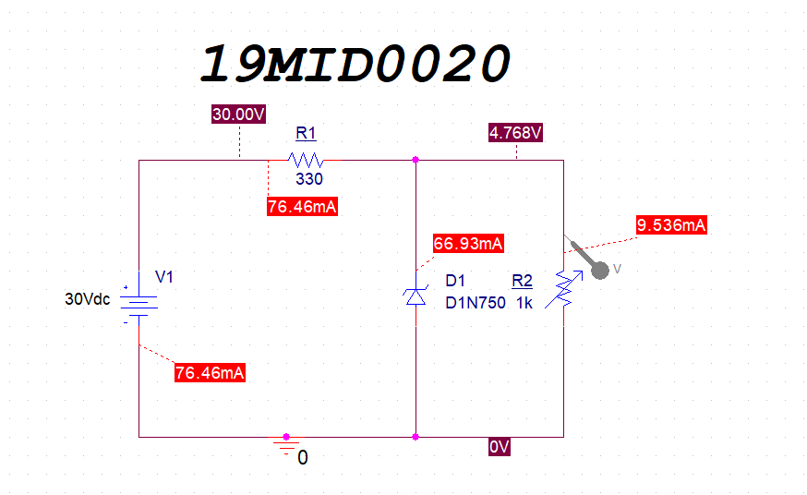

**Theory**

Zener diodes are generally used in the reverse bias mode. You have seen already in one of your previous experiments that the zener diode has a region of almost a constant voltage in its reverse bias characteristics, regardless of the current flowing through the diode. This voltage across the diode (zener Voltage, Vz) remains nearly constant even with large changes in current through the diode caused by variations in the supply voltage or load. This ability to control itself can be used to great effect to regulate or stabilize a voltage source against *supply* or *load* variations.

The output voltage across the load resistor, VL, is ideally equal to the zener voltage and

the load current, IL, can be calculated using Ohm’s law:



Thus the zener current, IZ, is



Now that you have constructed a basic power supply, its quality depends on its load and line regulation characteristics as defined below.

***Line Regulation:*** It indicates how much the load voltage varies when the input line voltage changes. Quantitatively, it is defined as:

$$Line Regulation= \frac{ΔV_{o}}{ΔV_{IN}}×100$$

where $ΔV_{o}=V_{L-high}-V_{L-low}$ = difference in the high and low output voltage, and

$ΔV_{IN}$ = difference in the high and low input voltage

***Load Regulation:*** It indicates how much the load voltage varies when the load current changes. Quantitatively, it is defined as:



where VNL = load voltage with no load current (IL = 0) or a very high value of load resistance (1K or above) and

VFL = load voltage with full load current or a very low value of load resistance.

The smaller the regulation, the better is the power supply.

**Procedure:**

1. Complete the rest part of the circuit as shown in the circuit diagram. Note down all the values of the components being used including the zener breakdown voltage.

2. Keeping RL fixed, vary the input voltage and measure again the output d.c. voltage, current and input d.c. voltage. (Will be need for line regulation)

3. Keeping input voltage suitably fixed, use different values of RL and measure both the output d.c. voltage and current.

4. Tabulate all your data and ***calculate percentage regulation in each case.***

**Observations:**

Specifications of zener diode: Breakdown voltage = 4.610V

RS = 330Ω

**Table (i) Line Regulation:** Load Resistor = 1KΩ

|  |  |  |
| --- | --- | --- |
| **Sl.No** | **Input DC Voltage (VIN) in Volts** | **Output DC Voltage (VL) in Volts** |
| **1** | **3** | **1.807** |
| **2** | **6** | **3.592** |
| **3** | **9** | **4.610** |
| **4** | **12** | **4.677** |
| **5** | **15** | **4.705** |
| **6** | **18** | **4.723** |
| **7** | **21** | **4.737** |
| **8** | **24** | **4.749** |
| **9** | **27** | **4.759** |
| **10** | **30** | **4.768** |

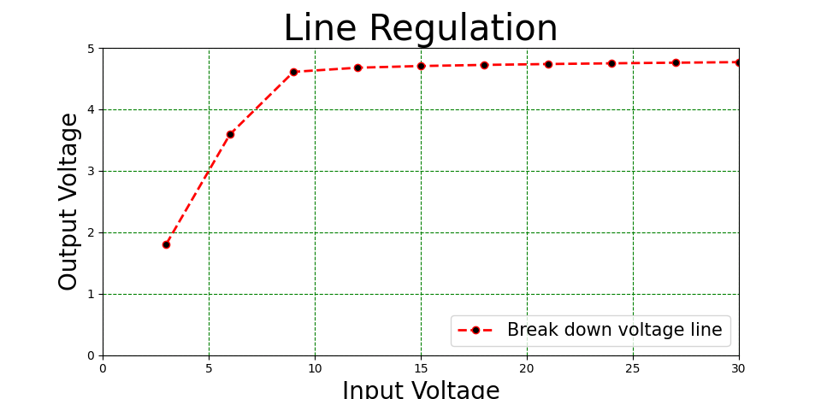

**Table (ii) Load Regulation:** Input DC voltage =10V

|  |  |  |
| --- | --- | --- |
| **Sl.No** | **Load Resistance in ohms** | **Output DC Voltage (VL) in Volts** |
| **1** | **10** | **149.3 mv** |
| **2** | **30** | **434.8 mv** |
| **3** | **50** | **704.2 mv** |
| **4** | **100** | **1.316** |
| **5** | **200** | **2.325** |
| **6** | **500** | **4.228** |
| **7** | **800** | **4.620** |
| **8** | **1K** | **4.643** |
| **9** | **2K** | **4.671** |
| **10** | **3K** | **4.677** |

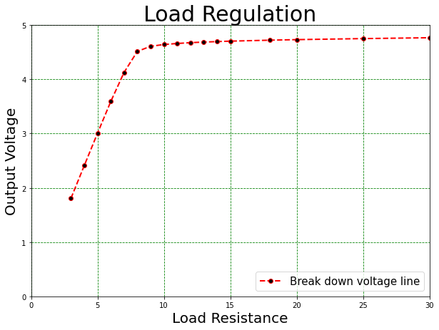

**Manual Calculation:**

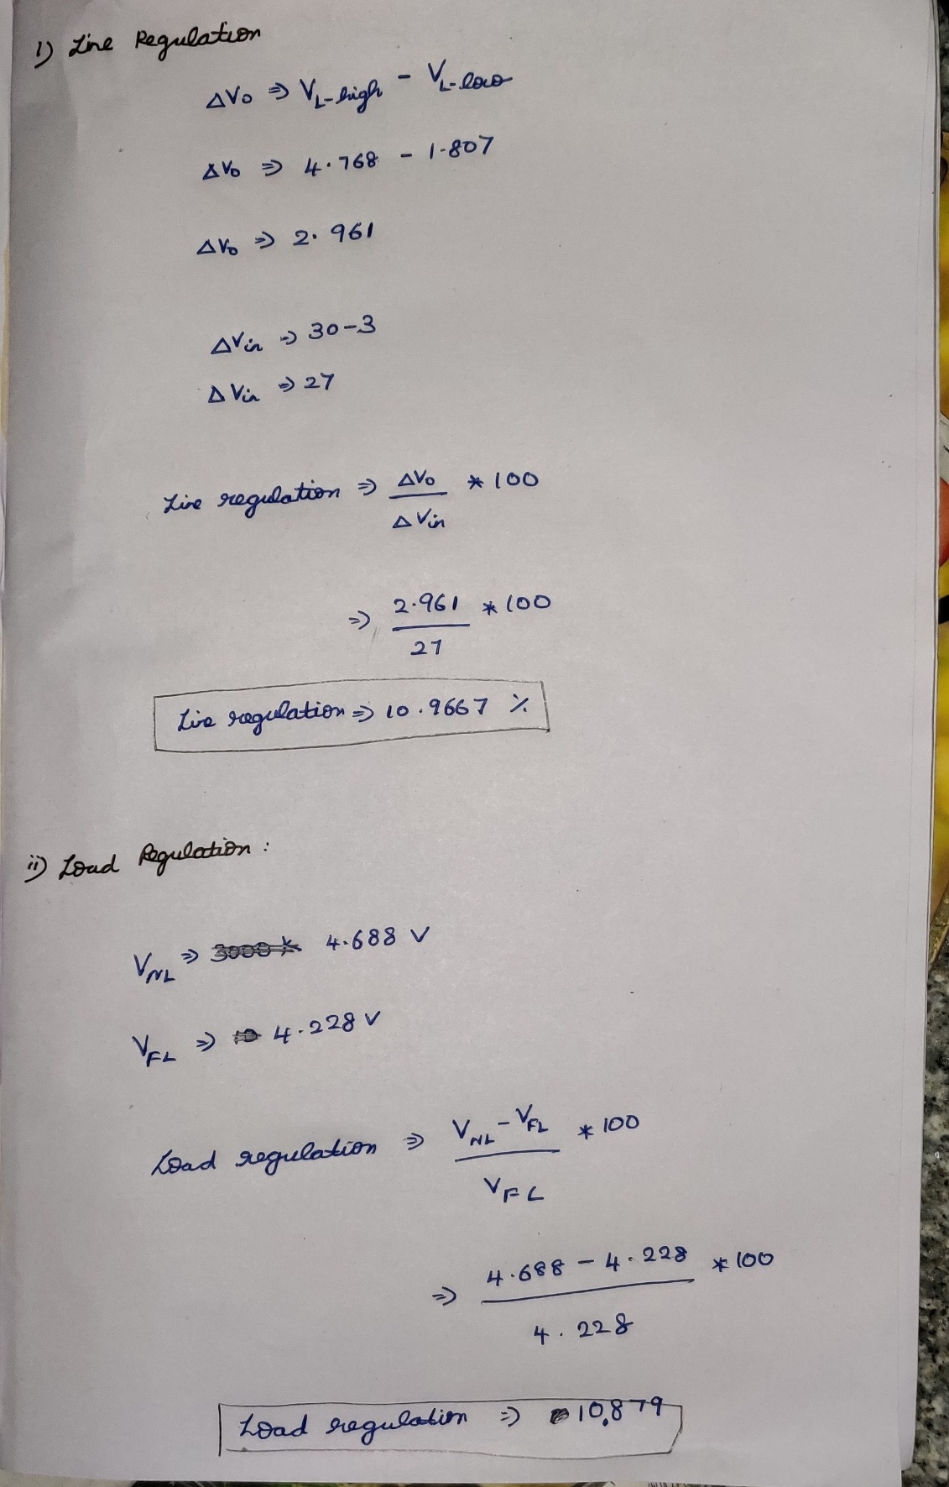

**Result:**

The Voltage regulation application of Zener diode is understood and proved using OrCAD Pspice Software.

**Conclusion:**

The **Zener diode**, with its accurate and specific reverse **breakdown voltage**, allows for a simple, inexpensive **voltage** regulator. Combined with the right resistor, fine control over both the **voltage** and the supply current can be attained.

**Reg. No: 19MID0020 Name:Prashanth.S Date: 23-10-2020**